IoT Based Smart Gadget for Child Safety and Tracking

# Literature Survey

1. Authors: M Nandini Priyanka, S Murugan, K. N. H. Srinivas, T. D. S. Sarveswararao, E. Kusuma Kumari.

Title: Smart IoT Device for Child Safety and Tracking.

Published in: 2019 IEEE.

The system is developed using Link-It ONE board programmed in embedded C and interfaced with temperature, heartbeat, touch sensors and also GPS, GSM & digital camera modules. The novelty of the work is that the system automatically alerts the parent/caretaker by sending SMS, when immediate attention is required for the child during emergency. Merits: The parameters such as touch, temperature & heartbeat of the child are used for parametric analysis and

results are plotted for the same.

Demerits: To implement the IoT device which ensures the complete solution for child safety problems.

1. Authors: Akash Moodbidri, Hamid Shahnasser Title: Child safety wearable device.

Published in: 2017 IEEE.

The purpose of this device is to help the parents to locate their children with ease. At the moment there are many wearable’s in the market which helps to track the daily activity of children and also helps to find the child using Wi-Fi and Bluetooth services present on the device.

Merits: This wearable over other wearable is that it can be used in any phone and it is not necessary that an expensive smartphone is required and doesn’t want to be very tech savvy individual to operate.

Demerits: As, this device’s battery gives short life-time. High power efficient model will have to be used which can be

.

frequency. GSM network consists of mobile station, base station subsystem network and operation subsystem. The GPS module is provided for identifying the location of the child. GPS module receives the signals from satellites. The latitude and longitude of the location can be identified by the GPS module. The device sends the monitored parameters data such as temperature and pulse rate to cloud. If any abnormalities occurs in temperature or pulse rate readings, a SMS and call triggers to the parent/caretaker mobile phone immediately and also updated to the mobile app only for the registries mobile no. We can use mobile application, cloud and database as the back end of storing and retrieving information and also a device for monitoring.

# Proposed System

1. *Safety Gadget*

Figure 1 shows the block diagram of the proposed child safety device. It consists of inbuilt Wi-Fi, GSM, GPS and Bluetooth modules. The link it one board is similar to the Arduino board and it is termed as all-in-one prototyping board for safety and IoT devices. The link it one is a robust development board for the hardware and also used for industrial applications. Different components such as temperature sensor, heartbeat sensor, panic button, contact switch are connected to the link it ONE board along with built in GSM, GPS modules. Safety gadget consists of BEACON and BLE packet is transmitted through it, this packet is received by binding gadget which has BLE receiver module, the packet usually contains information such as identification number, signal strength etc. Temperature is one of the most commonly measured variables. For measuring body temperature of the child DS18B20 temperature sensor is used. The heartbeat sensor is used in the proposed system for measuring the pulse rate. There is a heartbeat/pulse sensor which is combined to simple optical heart rate sensor with amplification and nullification circuitry making it is fast and easy to get reliable pulse reading. The GSM/GPRS block is activated with a SIM card on the board.

They mainly differ based on bandwidth and RF carrier

Fig. 1. Block diagram of smart gadget

1. *BLE Listener device*

Figure 2 shows the BLE Listener device is the device which is used to satisfy this feature along with safety gadget and parental phone. This gadget is also used to monitor safety gadget within a bounded area using wireless technology as follows, this feature of binding gadget is designed to work independently without phone network signal/internet so that safety gadget can even be under monitoring when it reaches remote areas where communication signals is not reachable like forest. Safety gadget consists of BEACON and BLE packet is transmitted through it, this packet is received by binding gadget which has BLE (Bluetooth Low Energy) receiver module, the packet usually contains information such as identification number, signal strength etc. Whenever the packet is received it checks for all the above information in the receiver device.

As the distance between safety gadget and binding gadget increases, the signal strength decreases. Once the safety gadget is moving out of threshold distance from the binding gadget then an alert is provided on binding gadget which will be used by parent/guardian.

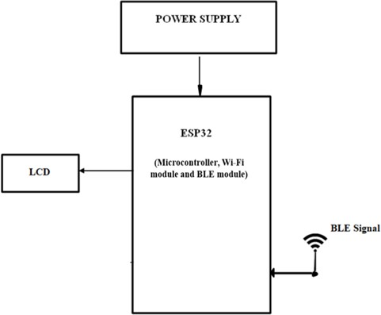

Fig. 2. Block diagram of BLE listener device

1. *Tools Used*

*Hardware Requirements:*

* + Arduino Mega [ATMEGA 2560].
  + GSM SIM 800C.
  + GPS Neo 6m.
  + 20X4 LCD.
  + I2C LCD Driver
  + 7805 Voltage Regulator.
  + Heart Beat Sensor.
  + DS18B20 Temperature Sensor.
  + 1x4 Switch.
  + ESP8266-12E
  + Push Button
  + Logic Level Convertor
  + Buzzer
  + LED
  + ESP32
  + OLED
  + Jumper Cables

*Software Requirements:*

* + Arduino IDE
  + Android Studio

*Languages Used:*

* + Embedded C
  + Java

# Methodology

This paper mainly focuses on child safety solutions which contain two major devices namely Smart gadget and BLE Listener device. The system also includes an Android app namely Parental App which will be developed and installed on parental phone.

This paper consists of 6 modules as follows:

1. *Live Location Tracking:* Safety gadget contains a GPS module which will fetch the current location and sends it to the microcontroller for required processing, the safety gadget is also installed with the GSM module to respond for location request sent via SMS from parental phone. The system is

connected to cloud via Wi-Fi technology and hence the GPS location is updated to the cloud at regular intervals or on request, whenever parent want to monitor the location of safety device then parental app can be used which fetches all the data from the updated cloud and also display the current/live location of the safety gadget.

1. *Panic Alert System:* The gadget is equipped with panic alert system feature which mainly consist of a button that is triggered only during certain abnormal/panic situations, this button is programmed in such a way that, once it is triggered then multiple alerts in various forms occurs within few seconds of time, SMS and also phone call is triggered to the parental phone from the safety gadget GSM module to the parental phone, which consists of current location of gadget fetched from its GPS and a pre-installed panic message seeking for help. An alert notification on parental app is triggered via Wi- Fi on safety gadget communicating to cloud where parental app receives the information.
2. *Stay Connected Feature:* This feature is to communicate between safety gadget (GSM module) and parental phone always connected irrespective of the situation, safety gadget can make a phone call anytime to parental phone and vice-versa. Safety gadget which will be displayed on its screen.
3. *Health Monitoring System:* The gadget consists of heart beat and temperature sensor which is used to monitor the general health condition of child. Any abnormalities being detected in the health monitoring parameters by the safety gadget then an immediate alert is sent on the parental app via Wi-Fi. Also, displays on parental app.
4. *Gadget Plug and Unplug Monitoring:* This feature is to keep monitoring if the safety gadget is plugged or not by monitoring the contact switch, necessary alerts are provided on parental app whenever the device is unplugged.
5. *Boundary Monitoring System:* Binding gadget is the device which is used to satisfy this feature along with safety gadget and parental phone. This gadget is used to monitor safety gadget within a bounded area using wireless technology. Once the safety gadget is moving out of the threshold distance from the BLE listener device then an alert is provided on device itself, which will be used by parent/guardian. This feature of binding gadget is designed to work independently without phone network signal/internet so that safety gadget can even be under monitoring when it reaches remote areas where communication signals are not reachable like forest.
6. *Software Specification*

The Arduino Software (IDE) which is an open-source and makes it easy to write the code as well as to upload in to the board. It runs on the Linux, Mac, IOS and Windows. The programs are written in Java, based on the Processing and other open-source software. This software makes the interfacing with Arduino-Uno much more reliable. The primary reason for using the GS shield as the mode of communication over Wi-Fi and Bluetooth was that this gadget was aimed at being accessible to any smartphone user. Also, to make the user- friendly as

possible.

Applications for the Android operating system are programmed using the SDK Android software development kit and Java programming language that also may be used with C or C++. The Android Studio is the official programming environment that allows developers to build Android apps. The idea behind the Android app has been derived from having an automated bot to respond to text message responses from the user. It will provide the user with pre-defined response options at just the click of a button. The user doesn't need to memorize the specific keywords to send. Also, the both will be pre- programmed to present the user with a set of pre-defined keyword options such as “DEVICE_LOCATION”.

# Results

* 1. *Live Location Tracking:* GPS is installed on gadget to track its current location can be tracked on android app and via SMS request sent from parent phone to safety gadget.

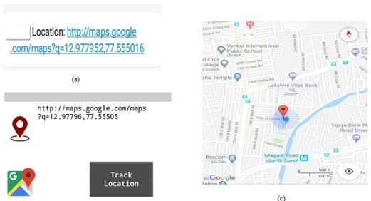

Fig. 3. Outputs of live location tracking

* 1. *Panic Alert Systems:* Panic alert system on gadget is triggered during panic situation, automatic call and SMS are triggered to parental phone. The alert is also updated to the cloud for purpose of app monitoring.

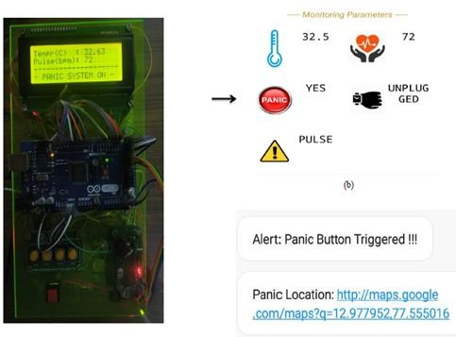

Fig. 4. Outputs of panic alert system

* 1. *Stay Connected Feature:* Stay connected feature is used to trigger call and pre-defined SMS anytime from gadget to parental phone by just pressing a button and also parent can make SMS and call to the gadget anytime.
  2. *Health Monitoring System:* Health monitoring system is implemented using heart beat sensor, temperature sensor which is updated to the cloud and also can be monitored via app. The current value of sensors can be obtained using SMS request sent to gadget from parent phone.

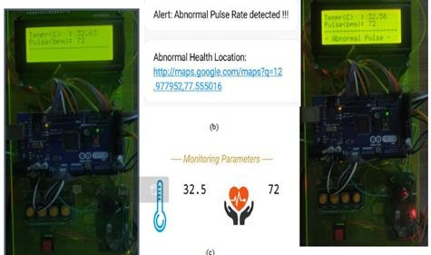

Fig. 5. Outputs of health monitoring system

* 1. *Gadget Plugged or Unplugged Monitoring:* Gadget plug or unplugged is monitored using contact switch installed on smart gadget, as soon as the device is unplugged, an alert is provided to parent phone via SMS and it is also updated to cloud for app monitoring.
  2. *Boundary monitoring system:* This is used to track the safety gadget using the binding gadget by implementing signal strength concept as soon as the safety gadget moves far away from the BLE listener gadget then an alert is provided to itself.

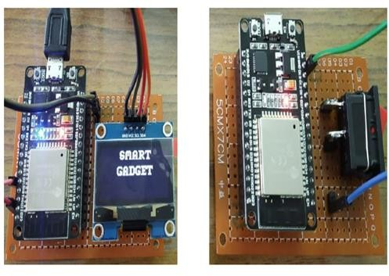

Fig. 6. Listener device and broad cast device

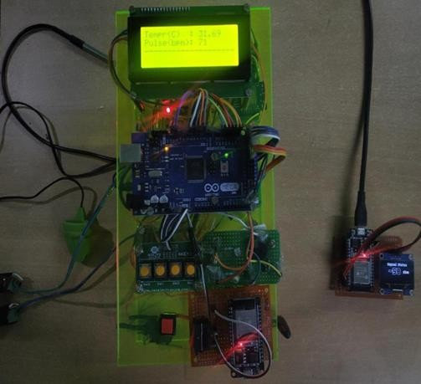

Fig. 7. Overview of safety gadget

Figure 7 shows the circuit connection with sensors. The temperature sensor, pulse sensor, BLE module, GSM module and GPS module are shown.

# Limitation

The system is dependent on communication signal/network signal for the smart gadget to trigger automatic phone call/SMS during panic situation. It can be difficult to detect when network

signal is not reachable/weak/when the smart gadget moves outside the boundary range. Hence, it can be improved by increasing the range.

# Conclusion

This research demonstrates Smart IoT device for child safety and tracking, to help the parents to locate and monitor their children.

If any abnormal readings are detected by the sensor, then an SMS and phone call is triggered to the parents mobile. Also, updated to the parental app through the cloud. The system is equipped with GSM and GPS modules for sending and receiving call, SMS between safety gadget and parental phone. The system also consists of Wi-Fi module used to implement IoT and send all the monitored parameters to the cloud for android app monitoring on parental phone. Panic alert system is used during panic situations alerts are sent to the parental phone, seeking for help also the alert parameters are updated to the cloud. Boundary monitoring system is implemented on safety gadget with the help of BEACON technology, as soon as the safety gadget moves far away from the BLE listener gadget an alert is provided to itself.

# Future Scope of Work

This system can be further enhanced by installation of mini- camera inside smart gadget for better security so that live footage can be seen on parental phone during panic situations. The system can be modified by installation of small solar panels for charging the battery of smart gadget to gain maximum battery backup.